Jurassic Coast Swimming
Winter Swim Challenge 2023-2024
November | December | January | February | March
w/c 28th Oct  28th Oct Winter Location swim & start of challenge  weekly mins/distance/bonus | w/c 2nd Dec  2nd Dec Pool Session  weekly mins/distance/bonus | w/c 30th December  1st Jan New Year Swim superheroes TBC  weekly mins/distance/bonus | 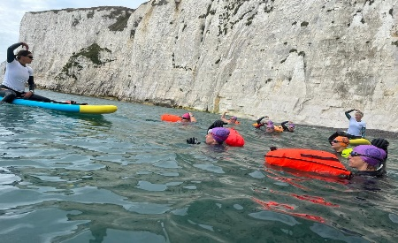 | w/c 2nd March  2nd Mar Winter Location Swim  weekly mins/distance/bonus
w/c 4th Nov  4th Nov Pool session  weekly mins/distance/bonus | w/c 9th Dec  15th Dec Xmas Party  weekly mins/distance/bonus | w/c 6th Jan  6th Jan Winter Location Swim  weekly mins/distance/bonus | w/c 3rd Feb  3rd Feb Winter Location Swim  weekly mins/distance/bonus | w/c 9th March  9th March Pool Session  weekly mins/distance/bonus
w/c 11th Nov  11th Nov Winter Location swim  weekly mins/distance/bonus | w/c 16th Dec  16th Dec Winter Location Swim  weekly mins/distance/bonus | w/c 13th Jan  13th Jan Pool session  weekly mins/distance/bonus | w/c 10th Feb  weekly mins/distance/bonus | w/c 16th March  weekly mins/distance/bonus
w/c 18th Nov  weekly mins/distance/bonus | w/c 23rd Dec  27th Dec Full Moon swim (weather dependent)  weekly mins/distance/bonus | w/c 20th Jan  25th Jan Full Moon swim (weather dependent)  weekly mins/distance/bonus | w/c 17th Feb  24th Feb Full Moon swim (weather dependent)  weekly mins/distance/bonus | w/c 23rd March  23rd March Pool session  25th March Full Moon swim  weekly mins/distance/bonus
w/c 25th Nov  27th Nov Full Moon swim (weather dependent)  weekly mins/distance/bonus | 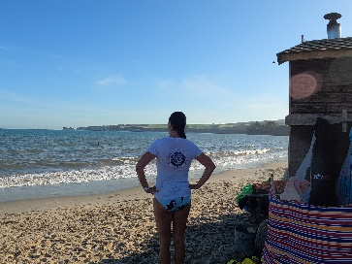 | w/c 27th Jan  27th Jan Pool Session  weekly mins/distance/bonus | w/c 24th Feb  24th Feb Pool session  weekly mins/distance/bonus | w/c 30th March  30th Mar Winter Location swim & End of challenge
Jurassic Coast Swimming
Winter Swim Challenge 2023-2024
Name: Wetsuit/skins:
JCS Winter swim challenge. 5 months of gradually decreasing water temperatures. Challenge yourself to swim every week through the winter months. Make a note of your distance OR time in the open water or simply tick the boxes weekly to say you have swum that week. Gain bonus points (meters/minutes) throughout with pop up quizzes on safety, first aid, water conditions, locations etc... and extra challenges. Prizes for winner in each category. No fee this year, unless you need a new hat. Some new challenges for you this year, see how many you can tick off.
☐Moonlight swim ☐Sunset swim ☐Sunrise swim ☐Lake swim ☐River swim ☐Swim in a Sea Pool ☐Swim in a different county ☐Spot a seal
☐Spot a sea anemone ☐Swim in a different country ☐Go Wave jumping ☐Swim in skins (wetsuit if you normally do skins!) ☐Double Dip Day
☐Triple Dip Day ☐Do 5 mins of Ocean aerobics with a friend ☐Swim every day for a week ☐Bake a cake and bring it to class (bonus points!)
☐Brownsea Island ☐Studland Bay ☐Swanage Bay ☐ Chapmans Pool ☐Kimmeridge Bay ☐Worbarrow Bay ☐ Mupe Bay ☐Lulworth Cove
☐Ringstead Bay ☐Osmington Mills ☐Church Ope ☐Chesil Cove
Winter Swim Gear Risks associated with Swimming in Cold Water Winter Timetable
Swim Gloves/socks Cold water shock Tuesdays 10.30 L1
Waterproof Dryrobe/Poncho Cramp Tuesdays 11.30 L2
Hot Drink & snack Cold water urticaria Wednesdays 10am L1&2
Bobble Hat & thick Socks Hypothermia Saturdays 11.30 L1&2
Tow float with ICE details After drop Saturdays 15.00 Pool
Mat to stand on while changing SIPE Monthly Location Swims
First Aid Kit
Hot water bottle
Always go for a brisk walk after swimming to make sure your core has warmed up. DO NOT just go and sit in a hot car
Never be tempted to swim alone, ESPECIALLY in the winter. If you agree to swim with someone ALWAYS turn up.
NEVER give in to peer pressure, listen to your body, if you feel cold GET OUT IMMEDIATELY.
NEVER treat one day the same as the next. Outside temperature, how you have slept, how much you have eaten, how you feel, ALL play a major part in how well your body copes with the cold water.
This is a fun challenge, NOT a competition. Please do not push yourself beyond your abilities.

